Oxfordshire County Council

HAILEY CE PRIMARY SCHOOL HOME SCHOOL AGREEMENT
Hailey School believes that in order to achieve our vision of providing the best starting block for children in our care, we must develop a healthy partnership with parents and pupils, where all staff, parents and children understand their responsibilities and work together towards the same goals.
We want to be recognised as the school of choice for parents in the local community. Through regular communication with the families at our school, we strive to promote close working and two-way support.
The purpose of this Home School Agreement is to outline the requirements for a productive and supportive home-school partnership. The key objectives are:
- to clarify the responsibilities of the school to its pupils and parents
- to clarify the responsibilities of parents to the school
- to set out the school’s expectations of its pupils
Hailey School’s Vision and Values
Our Vision for the Future
We aspire to provide the best starting block for children in our village and the surrounding area through the pursuit of excellence – in our provision for the children in our care, and also in our role in, and responsibilities to, our local community.

Our Aims
- To provide a safe, caring, loving environment that promotes core Christian and British values in our children, preparing them for their next school and in later life. We aim to equip them with the self-esteem, confidence, respect, resilience and tolerance to be responsible and contributing members of a global society.
- To inspire and achieve consistently outstanding attainment and progress by our children, challenging and supporting all pupils.
- To be recognised as the school of choice for families in the local community, balancing academic progress with the physical, moral, social and cultural development of their children.
- To be recognised as a school of choice for staff working in the education sector, providing a happy, productive working environment that supports and develops its staff.
To positively contribute to and support the local church and village community; being recognised with pride by those communities for our integral role in village life.
Our Values
We believe in:
- Promoting Christian values in our children and school community, particularly love & tolerance (respect for others) and instilling good behaviour.
- Providing our children, parents and staff with a caring, friendly, “family” atmosphere
- Inspiring a love of learning amongst our pupils which is supported by their parents
- Educating our children in, and celebrating, diversity in the UK and global society
- Working in harmony with our families, local church & village community & our partner schools
- Leading by example on trust and honesty, by our children, staff & governors
- Fulfilling our Mission Statement: “Together Everyone Achieves More”.
THE SCHOOL’S COMMITMENT
To provide the best education for your child, the school will:
- Care for your child’s safety and happiness, by providing a supportive, stimulating and respectful learning environment which treats all children equally
- Inspire your child to achieve their full potential as a valued member of the school community, both in terms of their learning and academic progress as well as their physical, moral, social, cultural and spiritual development
- Provide a consistently high standard of teaching, with a balanced curriculum to meet the individual needs of your child
- Provide appropriate levels of homework for your child to extend their independent learning, with clear information so that you will be able to help your child if required
- Achieve high standards of work and behaviour through building a stimulating relationship with your child and encouraging and celebrating their academic and personal achievements
- Encourage your child to develop a positive attitude towards others, regardless of any differences, based on our values of love and tolerance
- Keep you informed about the school, through newsletters and the website, including policies, events and news as well as providing updates about learning approaches that will help you support your child
- Keep you informed about your child’s progress, with constructive feedback and regular opportunities to meet with teachers including the Head Teacher
- Listen and respond appropriately to any pupil or parent concerns, discussing them respectfully and constructively at all times
- Be open and welcoming at all times and offer opportunities for you to get involved with the school to enrich the school experience
THE PARENTS’ / GUARDIANS’ COMMITMENT
To help my child thrive at school I / we will:
- Ensure my child comes to school every day (unless ill), on time, properly dressed in school uniform, properly equipped ( with their book bag, PE kit, drinks bottle and packed lunch if relevant) and ready to learn, with a good breakfast inside them.
- Make the school aware of any concerns, illness or problems that might affect my child’s attendance, work or behaviour so we can help manage them together.
- Encourage a positive, supportive attitude towards my child’s education and our school. If I have any concerns, I will come and discuss them with you promptly.
- Communicate with staff respectfully and constructively at all times, speaking to them as I would wish to be spoken to at home or in the workplace. (See code of conduct for parents and carers.)
- Support and adhere to the school’s values (love and tolerance) and the school’s policies on behaviour and equality which are based on self- discipline, high self- esteem and mutual tolerance and respect, and encourage my child to do the same
- Support my child in completing homework on time in a supportive learning environment. This does not mean doing it for them as this will give a false impression to their class teacher, but helping them if they get stuck and providing encouragement to try their best, even if they find it challenging.
- Helping them with other initiatives for home learning e.g. reading challenge, topic work etc as this is a critical part of their development.
- Attend parents’ evenings and discussions about my child’s progress, and work collaboratively with the teachers to nurture my child’s potential.
- Take an active interest in my child’s life and progress at school and become part of the school community, attending school events and performances when possible.
- Read school correspondence concerning policies, information, surveys and events and respond promptly to requests for information, including those that will support the development of our school.
- Uphold the school's policies relating to this Agreement, especially those associated with safeguarding, conduct and health and safety. This includes a commitment for parents and children to behave responsibly on social media concerning school activities and not post photographs of children at school events or make derogatory comments about any member of the school community, be it parents, staff, governors or pupils.
- Support the school and the Friends of Hailey School when possible with their activities for the benefit of the pupils and, where possible, contribute voluntary donations to support specific extracurricular activities for my child.

THE PUPILS’ COMMITMENT
The School Rules were developed by pupils and staff together at Hailey School.
To help me do well at school I will:
- Bring the things I need to school every day and look after them properly
- Make sure I’ve had enough sleep and a good breakfast so I am ready for learning
- Drink water through the day and eat my lunch
- Respect the school rules so we can all learn together
- Be responsible for my school and homework and hand it in on time
- Ask for help if I need it and try my best
- Act with love and tolerance ( our school values ) with everyone at our school
- Take care of myself, our school and its equipment and grounds
- Talk to a member of staff if I am worried or unhappy
- Take home school letters and remember to give them to my parents / guardians
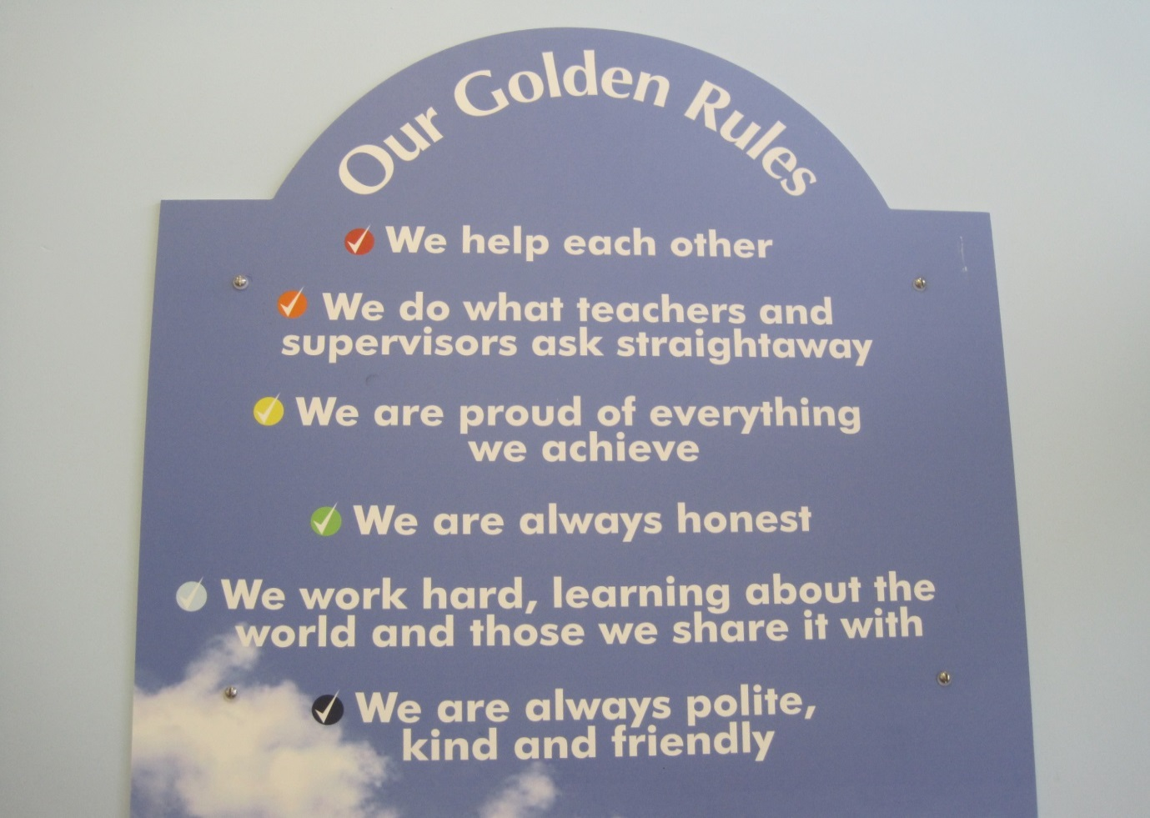

Please read and discuss this agreement with your child, and then both sign the enclosed form. If you have any questions about the agreement please contact the Head Teacher who will be happy to help you.
The school has a number of policies relating to this agreement which are available on our website or on request from the school office. These are:
Anti-bullying Policy
Attendance Policy
Behaviour Policy & Principles
Child Protection Policy
Code of Conduct for Parents & Carers
Complaints Policy
Curriculum Statement
Health and Safety Policy
Homework Policy
Children with Medical Needs Policy
Photographic Policy
Single Equality Policy
Special Educational Needs & Disability Policy
New Technologies Policy

